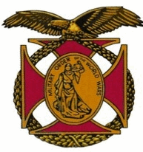

Meeting of the General J. P. Holland Chapter of the MOWW
March 5th, 2016

The Chapter gathered at the Bernardo Heights Country Club at 1100

The meeting was called to order at 1130 by Chapter Commander, Nick Herbka. Chaplain Bruce Charnov offered the invocation, Earl Wentworth led the Pledge of allegiance, and Tom Lettington read the Preamble.

New Business:
- Former Commander in Chief, Debbie Kash conducted an induction ceremony for new Chapter Companions James and Sharon Oster.
- Companion Travis Putnam, President of the San Diego Youth Leadership Conference conducted an interview with an attendee of last year’s YLC to emphasize the benefit young attendees obtain from their participation. He also presented aYLC introductory overview of the program.

Lunch was served at 1215

After lunch the guest speaker, Gerdy Uyleman Anthonijs, gave a talk about her experiences during World War II in the Dutch East Indies

Following her presentation, Nike Herbka and Tom Lettington presented a Certificate of Appreciation. Chapter Challenge coins were presented to our Guest Speaker and her husband of 66 years.

Chaplain Charvov gave the benediction, and the meeting was adjourned at 1405.

